

YES PANCHI

Raksha
Enterprise AI Security & Data Governance

Index
Section 6.3.8 VI Security Controls Directory

S.No | Topic / Security Control | Page Number
6.3.8 VI (a) | Automatic Redaction  PII blocking & redaction (Aadhaar, PAN, contact details) | Page 3
6.3.8 VI (b) | Malicious Intent Detection  Mass extraction, enumeration patterns & jailbreak defense | Page 4
6.3.8 VI (c) | Prompt Sanitization  Incoming query analysis & classified personal data protection | Page 4
6.3.8 VI (d) | Clipboard & Data Governance  Strict controls on Copy-Paste, Drag-and-Drop & Downloads | Page 5
6.3.8 VI (e) | Policy Enforcement  Purpose alignment, consent validation & minor/children data | Page 5
6.3.8 VI (f) | Just-in-Time (JIT) Coaching  Real-time browser-level alerts & employee education popups | Page 6
6.3.8 VI (g) | Response Scanning  AI-generated response analysis & classification metadata | Page 6
6.3.8 VI (h) | Risk Scoring  Regulatory & business risk scoring for AI responses & search | Page 7

6.3.8 VI (a): Automatic Redaction
6.3.8 VI (a) | MANDATORY SECURITY SPECIFICATION
"Automatic Redaction: The solution must automatically block or redact PII (e.g., Aadhaar, PAN, contact details) from natural language prompts before transmission to any AI service."
Technical Compliance & Implementation: Raksha continuously enforces real-time inspection on all natural language prompts before transmission across any monitored AI interface (e.g., ChatGPT, Claude, Gemini). Administrators define custom DLP rules utilizing precise regular expressions for Aadhaar (e.g., [2-9]{1}[0-9]{3}\s[0-9]{4}\s[0-9]{4}), Permanent Account Numbers (PAN), and phone numbers. When an employee attempts to send a prompt containing PII, Raksha intercepts the network request at the DOM level and either instantly aborts the transmission (BLOCK mode) or masks the sensitive tokens (REDACT mode) prior to dispatch.
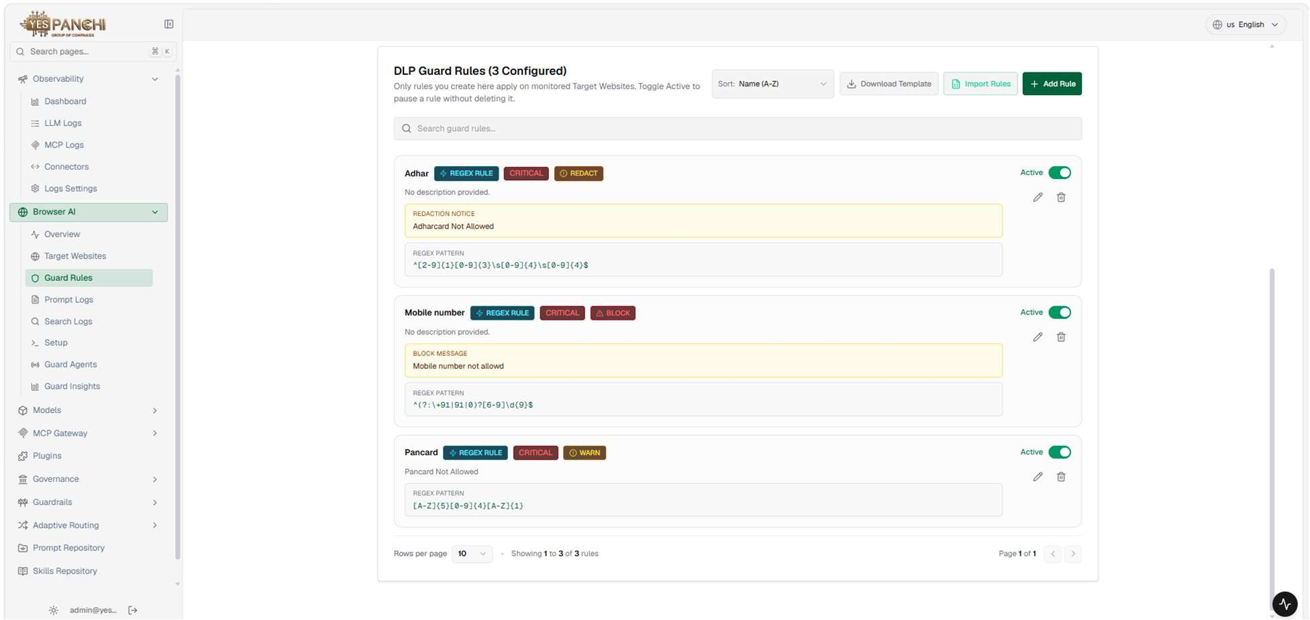
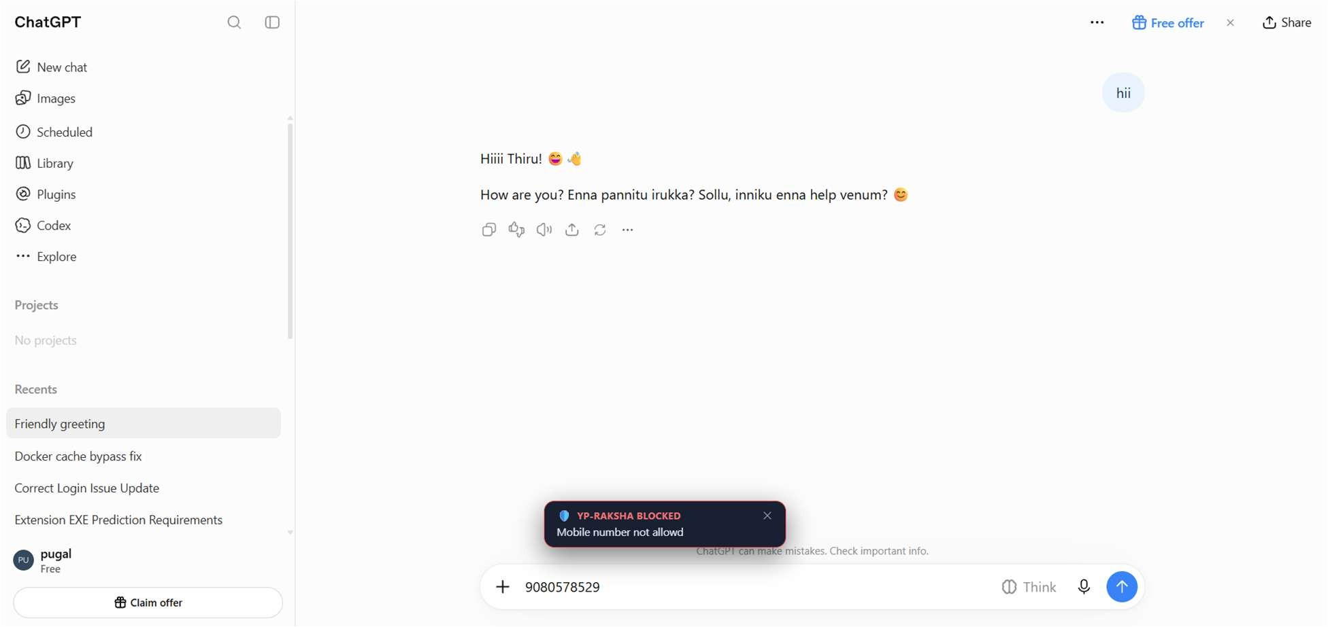

Figure 1.1: Raksha DLP Guard Rules Console configuring real-time Aadhaar, Mobile Number, and PAN Card detection filters.

Figure 1.2: Live in-browser prompt interception on ChatGPT blocking submission and rendering instant alert toast.

6.3.8 VI (b): Malicious Intent Detection
6.3.8 VI (b) | MANDATORY SECURITY SPECIFICATION
"Malicious Intent Detection: The system shall inspect prompts for mass extraction, enumeration patterns, or manipulation attempts (jailbreaking) designed to bypass security controls."
Technical Compliance & Implementation: Raksha analyzes input prompts for structural and semantic anomalies indicating jailbreak exploits, prompt injection, SQL injection patterns (e.g., ' OR '1'='1'), and automated enumeration attacks. Rules trigger instant blocking and security incident telemetry when mass data harvesting patterns are detected.
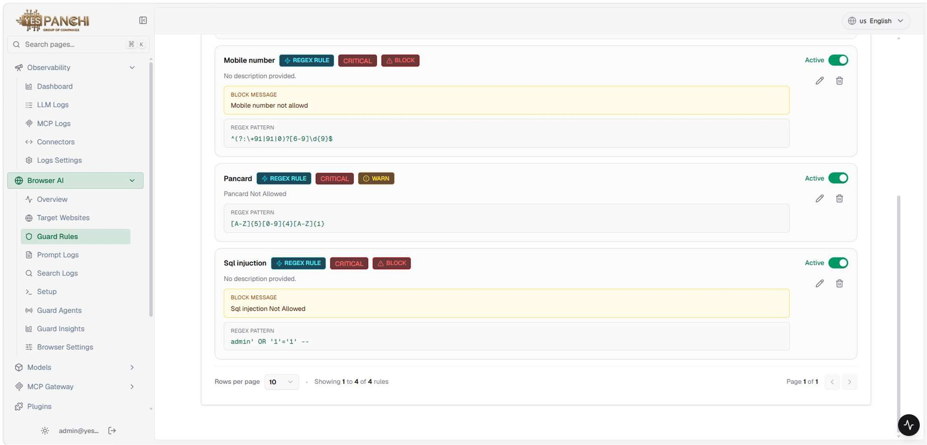

Figure 2.1: Active DLP Guard Rules in Raksha detecting SQL injection, jailbreaking vectors, and malicious enumeration patterns.

6.3.8 VI (c): Prompt Sanitization
6.3.8 VI (c) | MANDATORY SECURITY SPECIFICATION
"Prompt Sanitization: All incoming queries must be analysed to prevent the unauthorized retrieval of classified personal data."
Technical Compliance & Implementation: All user queries entering AI services undergo deep packet and text token inspection against classified personal data dictionaries. Unsanitized requests containing proprietary employee IDs, customer contact information, or confidential records are sanitized or blocked, ensuring zero leakage of classified identifiers.
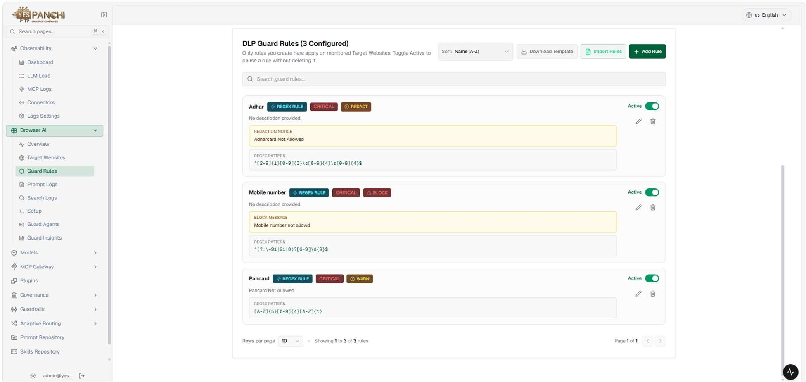

Figure 2.2: Raksha Prompt Sanitization pipeline continuously inspecting incoming queries for classified personal data.

6.3.8 VI (d): Clipboard & Data Governance
6.3.8 VI (d) | MANDATORY SECURITY SPECIFICATION
"Clipboard & Data Governance: The vendor must enforce strict controls to prevent "Copy-Paste" or "Drag-and-Drop" of sensitive corporate data into unauthorized browser-based AI tools or extensions."
Technical Compliance & Implementation: Raksha's Browser Guard enforces kernel- and DOM-level hooks intercepting browser clipboard operations, file drag-and-drop events, and file uploads. Administrators can independently enforce Copy-Paste Strict Blocking, Drag-and-Drop Injection Blocking, and File Download & Export Blocking globally or scoped to specific AI platforms.
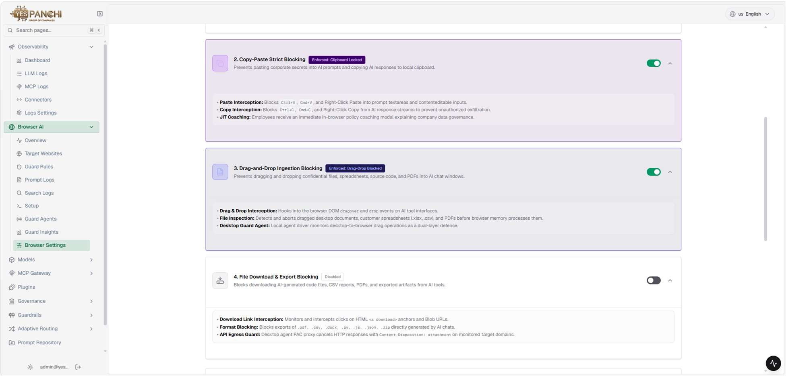

Figure 3.1: Browser Settings console showing active Copy-Paste Strict Blocking, Drag-and-Drop Blocking, and File Export Controls.

6.3.8 VI (e): Policy Enforcement
6.3.8 VI (e) | MANDATORY SECURITY SPECIFICATION
"Policy Enforcement: Before processing, the solution must validate that requests align with the declared purpose and block prompts involving expired/withdrawn consent or children’s data."
Technical Compliance & Implementation: Before any query is forwarded to an AI engine, Raksha validates policy compliance against corporate usage guidelines. This includes automated content classification rules blocking inappropriate content (e.g., 18+ adult material filters), unauthorized biometric/Aadhaar data masking, and purpose-alignment validation preventing unauthorized processing of minors' data.
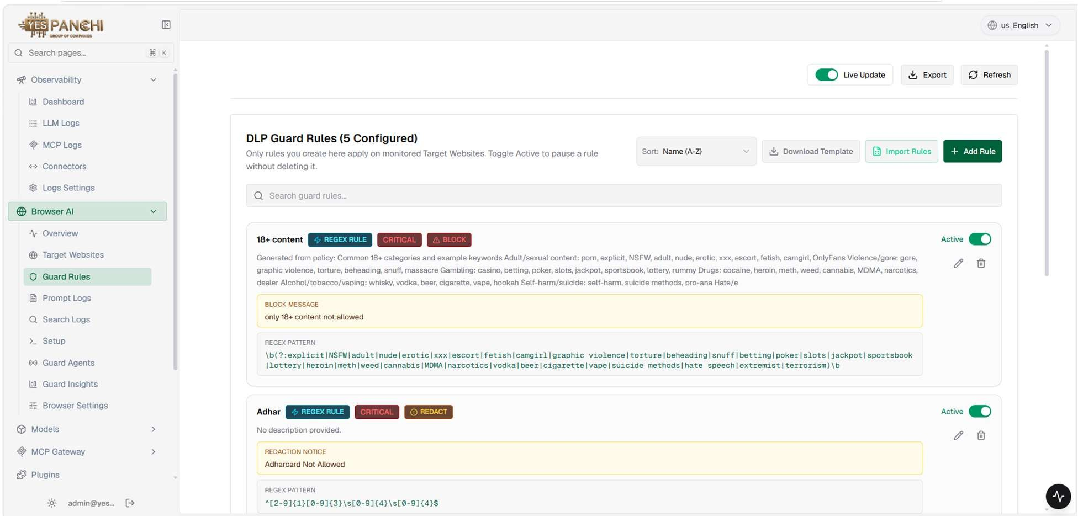

Figure 3.2: Multi-tier DLP Policy Rules enforcing content classification, consent safeguards, and restricted data blocking.

6.3.8 VI (f): Just-in-Time (JIT) Coaching
6.3.8 VI (f) | MANDATORY SECURITY SPECIFICATION
"Just-in-Time (JIT) Coaching: The solution shall provide real-time, browser-level pop-ups to educate and alert employees whenever a data policy violation is intercepted."
Technical Compliance & Implementation: Rather than silently failing, Raksha provides immediate in-context education to employees. Upon detecting a data policy violation, the in-browser extension renders an unobtrusive yet authoritative toast alert (e.g., YP-RAKSHA BLOCKED: Mobile number not allowed). This reinforces corporate security culture while stopping sensitive data from leaving the workstation.
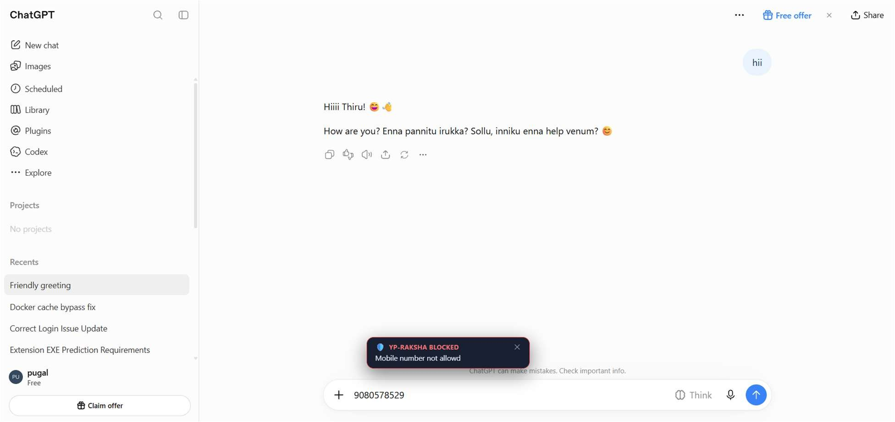

Figure 4.1: Real-time JIT coaching notification popup displayed in ChatGPT educating employee upon intercepted mobile number input.

6.3.8 VI (g): Response Scanning
6.3.8 VI (g) | MANDATORY SECURITY SPECIFICATION
"Response Scanning: All AI-generated responses must be analysed for PII or sensitive content and evaluated against established classification metadata."
Technical Compliance & Implementation: Raksha provides bidirectional security. Beyond intercepting outbound prompts, the system captures and inspects all inbound AI responses. Responses are evaluated against classification metadata, calculating an automated Response Risk Score (e.g., 6% LOW), threat level, and safety category, ensuring AI outputs do not leak proprietary information back into employee workspaces.
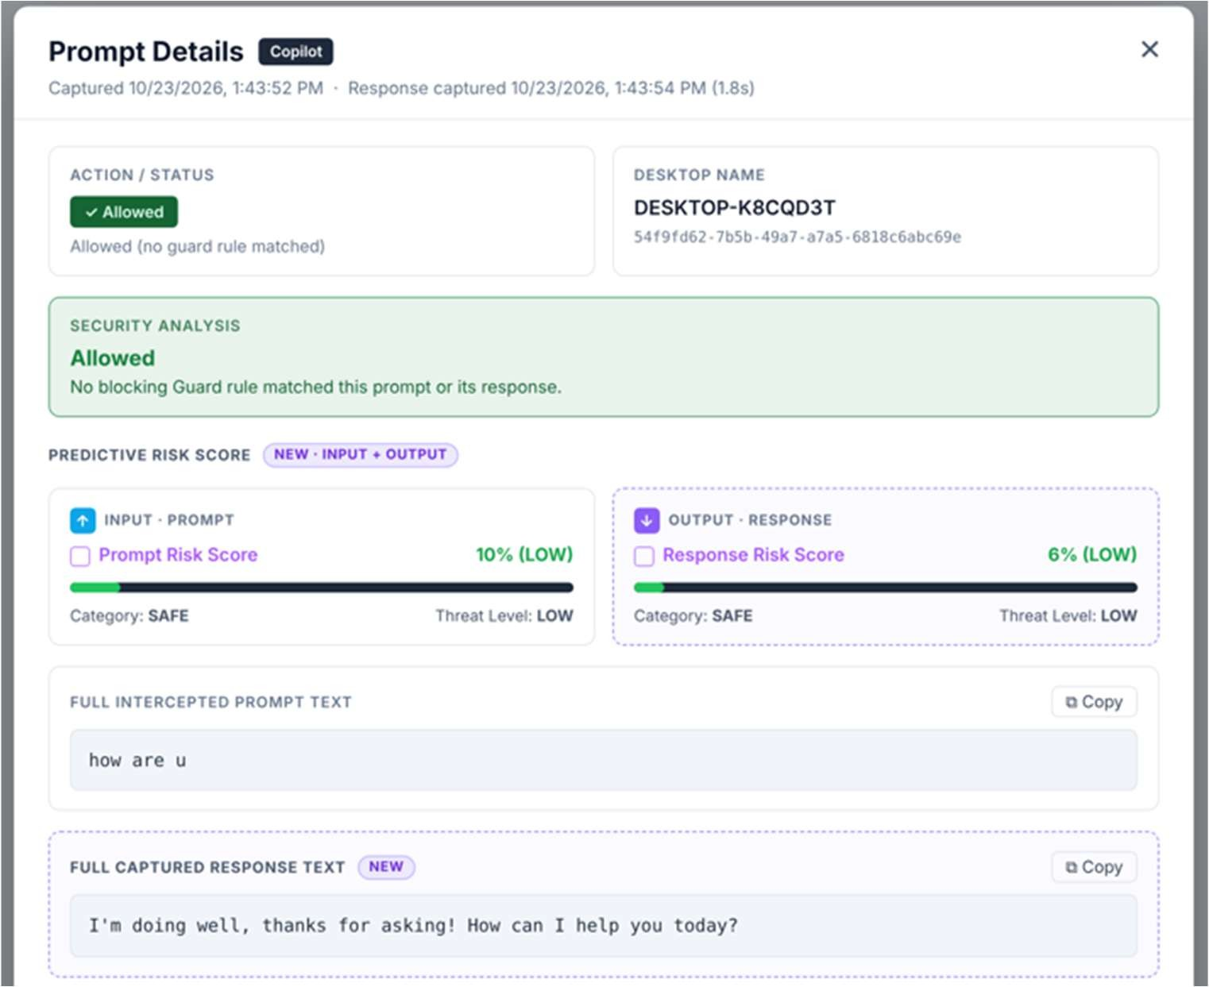

Figure 4.2: Prompt Details modal displaying automated Response Risk Score (6% LOW), safety classification, and captured response text.

6.3.8 VI (h): Risk Scoring
6.3.8 VI (h) | MANDATORY SECURITY SPECIFICATION
"Risk Scoring: The solution shall assign a regulatory and business risk score to every AI response to ensure ongoing compliance."
Technical Compliance & Implementation: Raksha incorporates a multi-dimensional risk engine that scores every user prompt, AI model output, and search engine query. The system aggregates risk indicators (threat category, PII density, regulatory classification) to assign numerical and categorical risk scores (LOW, MEDIUM, HIGH, CRITICAL). Real-time telemetry dashboards provide security teams with continuous audit visibility.
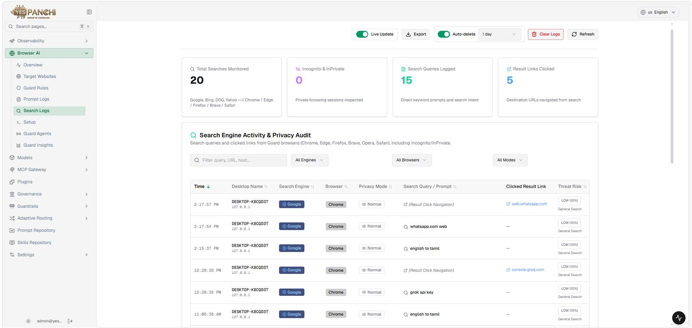
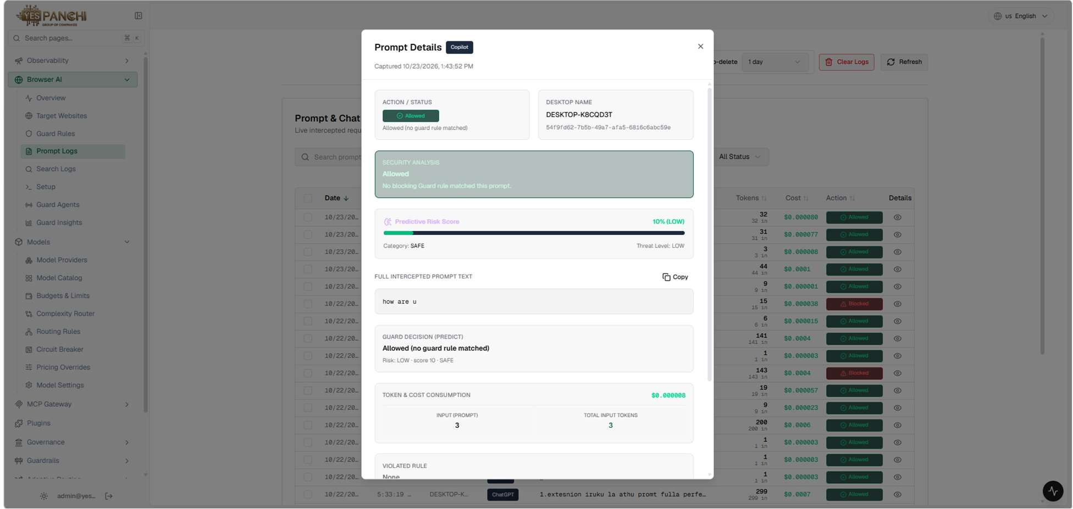

Figure 5.1: Search Engine Activity & Privacy Audit dashboard displaying monitored queries, privacy modes, and risk score metrics.

Figure 5.2: Detailed Interaction Log and Risk Scoring table assigning risk ratings to every prompt and response.

The solution must automatically discover AI tools, AI agents, AI chatbots, and AI model integrations used across the enterprise environment.
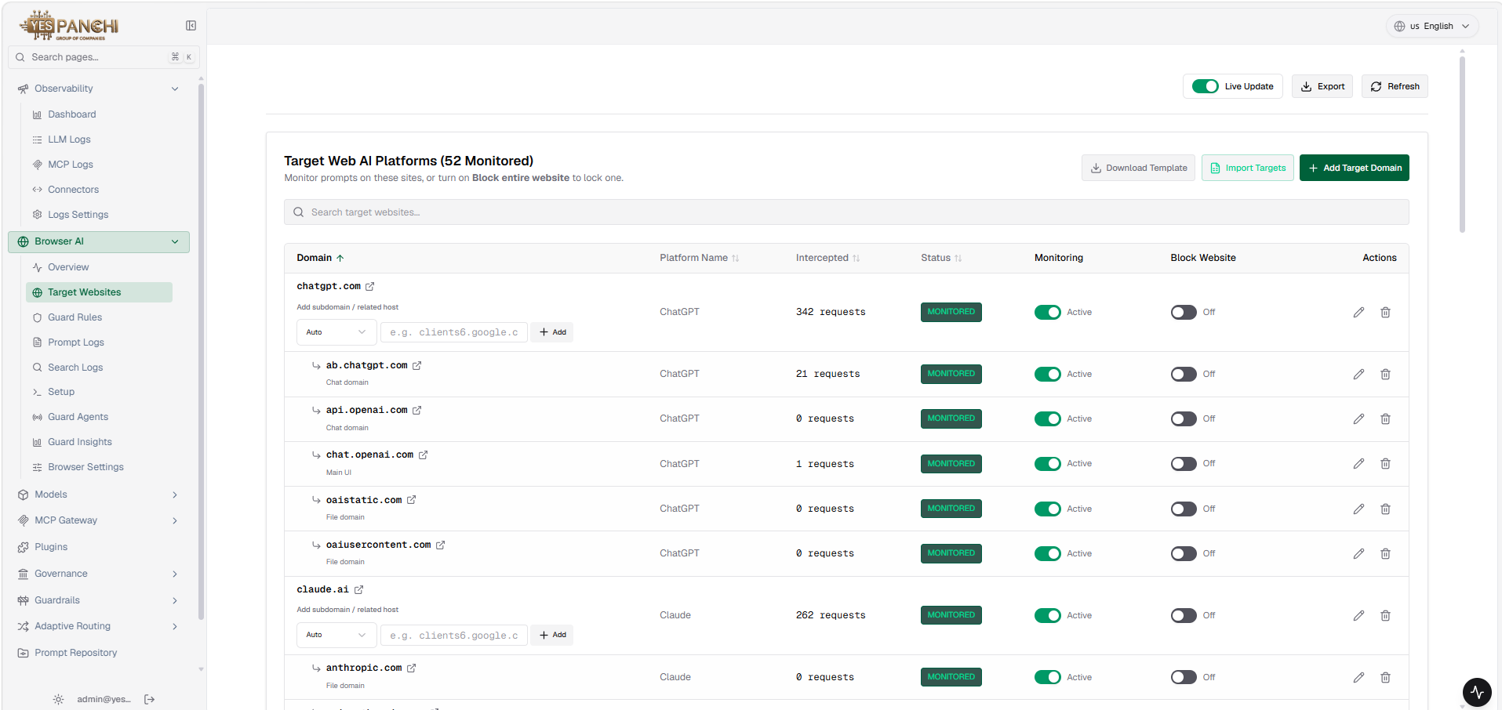

The solution should provide visibility into AI tool usage across users, applications, and data repositories.
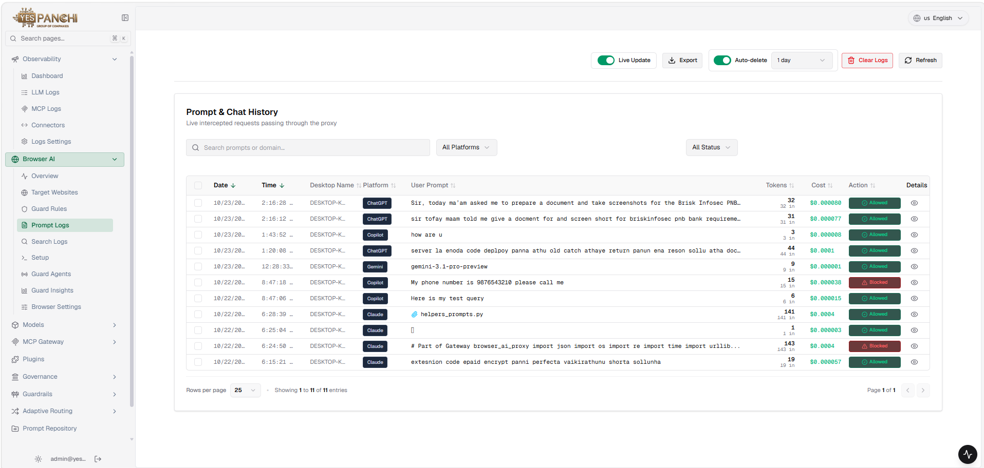

The solution must identify shadow AI usage, including unauthorized AI applications and browser-based AI tools.
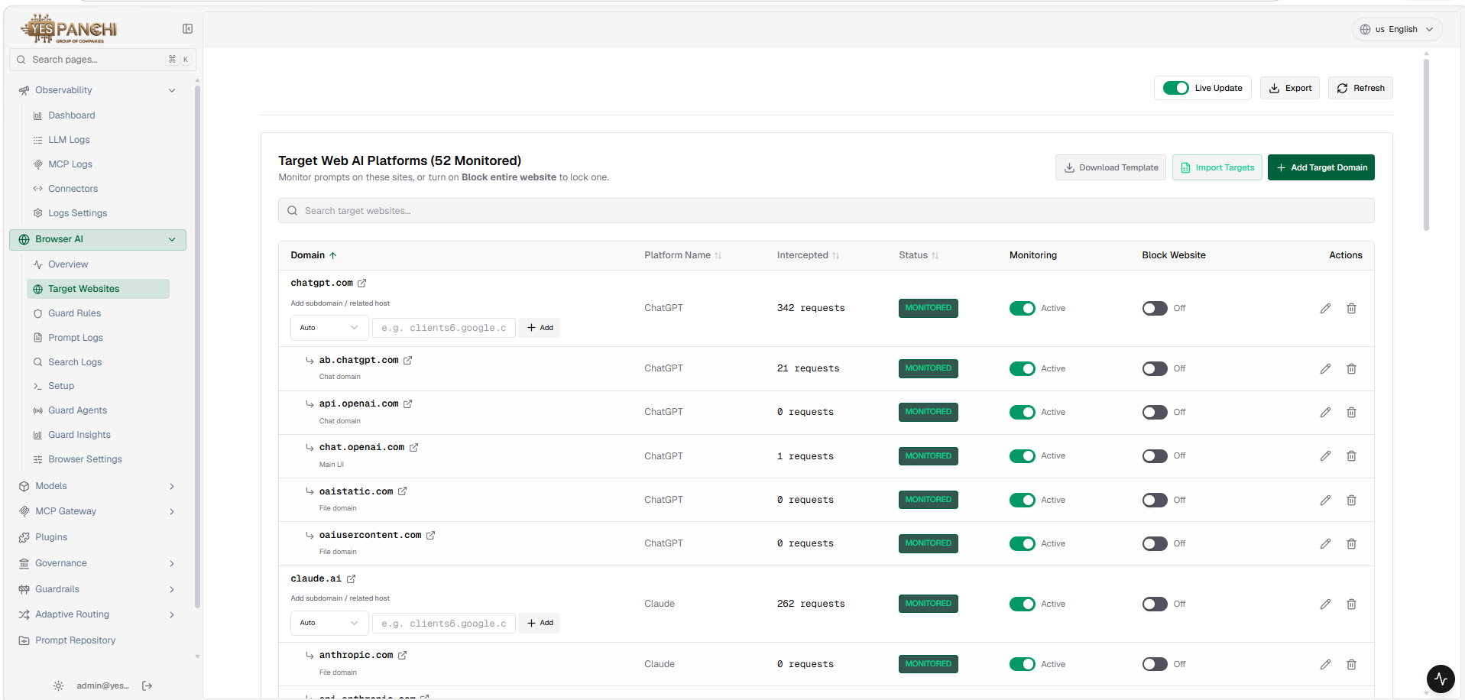
The solution should monitor AI interactions with enterprise data repositories including file systems, collaboration platforms, and cloud storage. 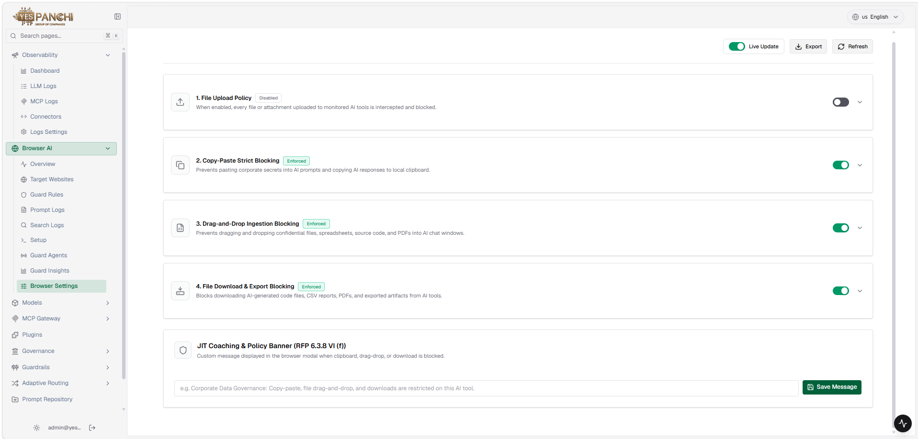
The solution must provide continuous monitoring of user interactions with AI tools to detect potential data leakage risks. 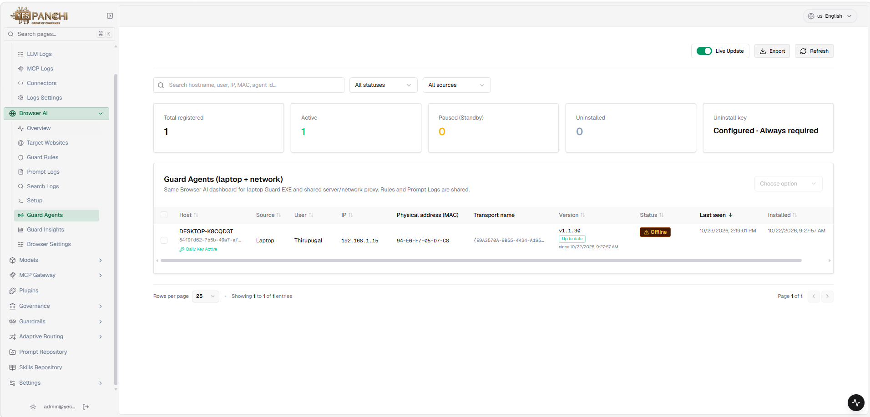
The solution should detect when sensitive or regulated data is being accessed or transmitted through AI applications. 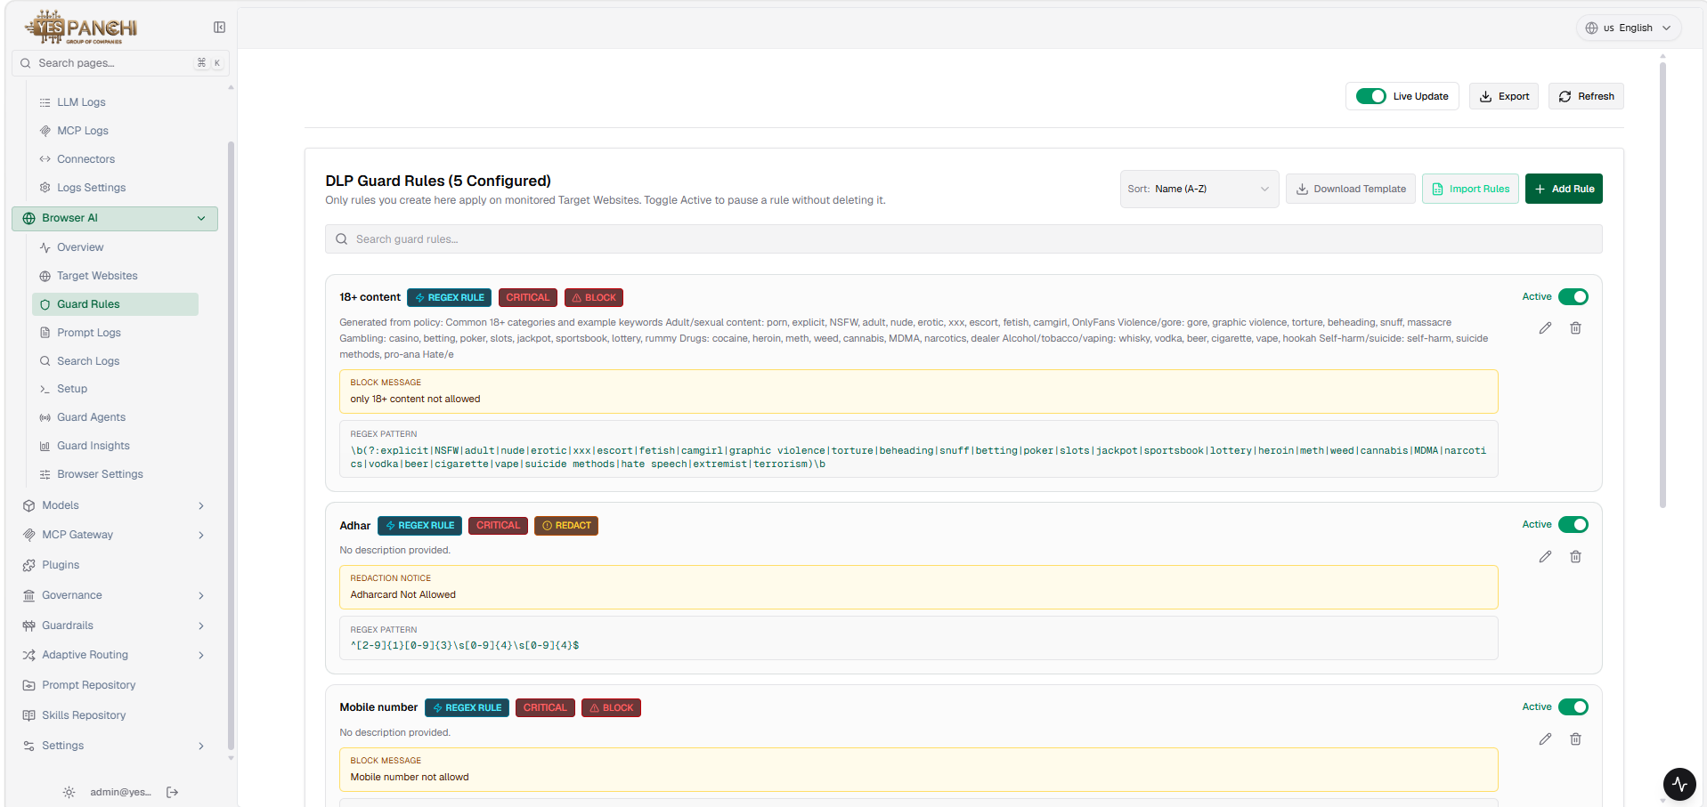
The solution must provide policy-based controls to restrict the exposure of sensitive data to AI tools and services.
The solution should support automated enforcement of AI data protection policies.
The solution must identify sensitive enterprise data accessed by AI systems, including personal data, financial data, and intellectual property.
The solution should classify sensitive data accessed by AI systems using automated classification mechanisms.
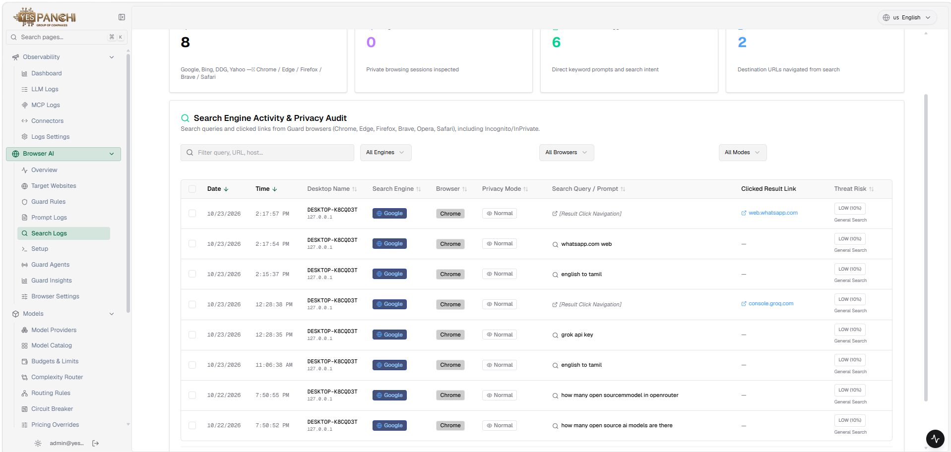
The solution must provide risk scoring for AI systems based on the sensitivity of data they access.
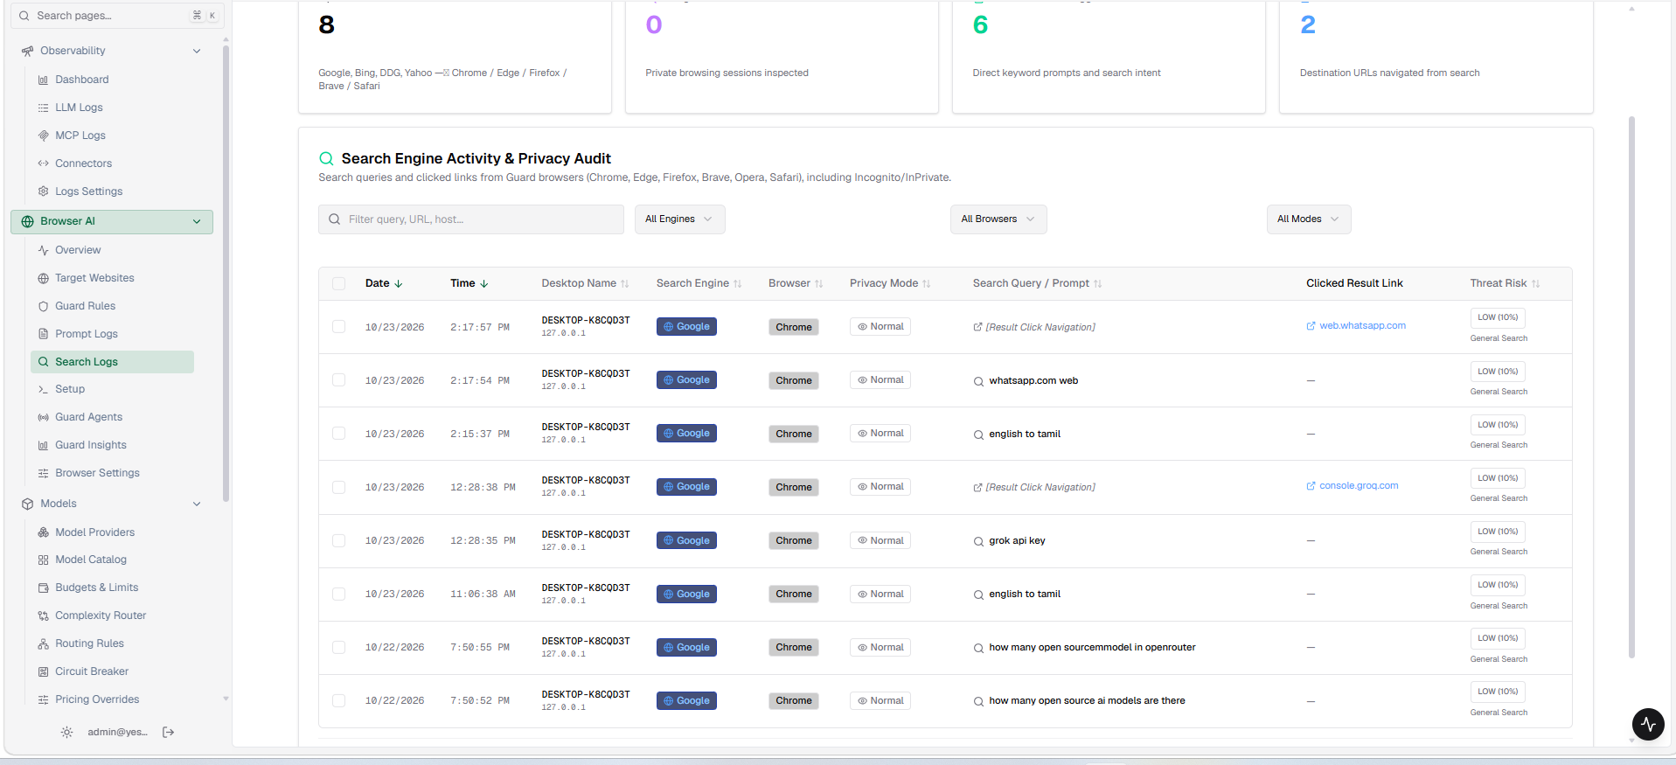
The solution must provide risk scoring for AI systems based on the sensitivity of data they access.
The solution should detect when AI tools attempt to access excessive or unnecessary data.
The solution must provide the ability to restrict AI model access to sensitive datasets based on predefined policies.
The solution should monitor and detect anomalous AI data access patterns that may indicate misuse or compromise.
The solution must detect abnormal or suspicious interactions between AI systems and enterprise data sources.
The solution should generate alerts for potential data exfiltration attempts through AI applications.
The solution must detect abnormal AI usage patterns such as excessive prompts, automated extraction attempts, or data scraping behaviour.
The solution should support investigation workflows for security analysts to review AI-related security events.
The solution must maintain detailed audit logs of AI activity and data access events.
The solution must provide governance controls for enterprise AI usage aligned with organizational security policies.
The solution should generate compliance reports related to AI data access and AI system usage.
The solution must provide dashboards for security teams showing AI risk posture across the enterprise.
The solution should support audit reporting for regulatory or internal governance requirements.
The solution must enable policy enforcement to prevent AI tools from accessing restricted or classified datasets.
The solution must support runtime monitoring of AI interactions with enterprise data.
The solution should detect prompt-based attacks such as prompt injection or manipulation attempts.
The solution must prevent AI systems from exposing sensitive information through responses or outputs.
The solution should support automated remediation actions such as blocking AI requests, restricting access, or generating alerts.
The solution must provide centralized dashboards displaying AI risk exposure across users, systems, and data assets.
The solution should provide analytics on AI adoption trends, usage patterns, and risk indicators.
The solution must provide risk scoring for AI activities based on data sensitivity and user behaviour.
The solution should support executive reporting for security leadership and risk management teams.

